For Telecom Australia
Use Only

Research
Laboratories
Report FFFF

Personal Recollections
of Telecom Research
Laboratories:
1981 to 2005

By J. Stephen Spicer


Telecom Australia

AUSTRALIAN TELECOMMUNICATIONS COMMISSION.
Research Laboratories.

Personal Recollections of Telecom Research
Laboratories: 1981 to 2005, by J. S. Spicer,
Melbourne, 2005.

Report No. FFFF (Version 1.1 – corrected 25 Jan 2006)

I. SPICER, J. S.
1. TELECOM RESEARCH LABORATORIES
2. HISTORY
3. PERSONAL

RESEARCH LABORATORIES REPORT FFFF

PERSONAL RECOLLECTIONS OF TELECOM RESEARCH
LABORATORIES: 1981 TO 2005.

1. INTRODUCTION.

I have decided to christen this report with the sequence number FFFF to signify that it is the last Research Laboratories Report (RLR) that will be written by an employee of the Australian Telecommunications Commission.

I apologise to all other employees of the Research Laboratories for having the audacity to assume that this is the last RLR from TRL.

This report is merely a personal perspective – it is not in any sense a history of the Research Laboratories during my time here - such a document would require many, many authors. Instead, this report is a vehicle to collect some of the insignificant (and not so insignificant) events that happened to me at the Laboratories.

2. REPORT FORMAT

The typesetting, cover-sheet and format in which this report is presented mimics that used by the Research Laboratories during the mid 1980’s.

During the 1990’s the publication of RLR’s decreased. The written output from TRL (and of communication more generally throughout Telstra) migrated to a new form – that of the Powerpoint-Slidepack.

This report is a hybrid of both forms of written publication. The reason for this is:

* The physical typesetting is a reminder of how things once were.

* The bullet-point based form of communication used in PowerPoint slide-packs is used, as many staff can only consume information in this format.

NB: There is some international concern that the PowerPoint form of communication is too restrictive. For example, see this version of The Gettysburg Address:-
http://www.norvig.com/Gettysburg/

I also acknowledge previous staff member Rick Coxhill (www.coxhill.com) for influencing the format of this report.

3. INCIDENTS AND MEMORIES

- Most enjoyable project
  - The design and commissioning of the Telstra Media Lab (1995).

- Most rewarding project
  - The cost & network-modelling of large-scale video-on-demand delivery systems

- Most Frustrating Project Work
  - VISTA (Video Indexing with Stored Text Access) – 1995.
    - If there was ever proof of Telstra’s inability to identify something worth commercialising, this is it. This was leading-edge application development work, some of which we are just beginning to see emerge now (ten years on), but by other vendors, not Telstra.
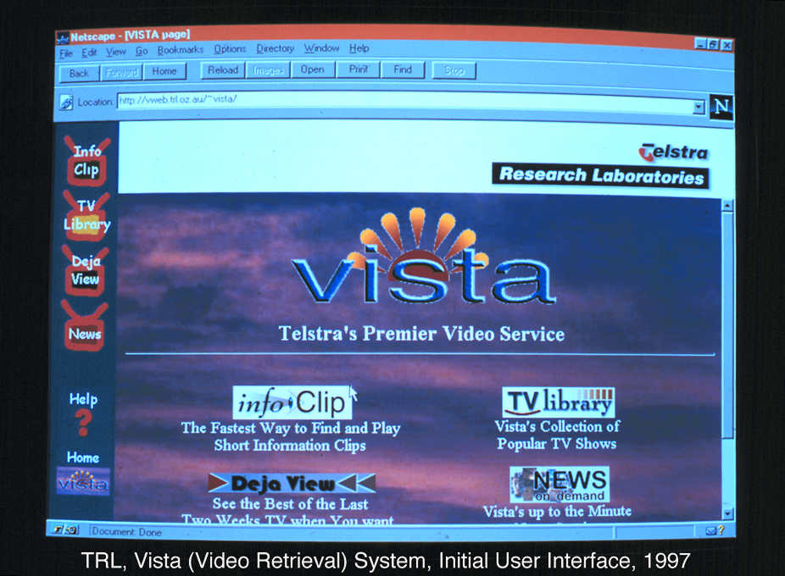

- Silliest Asset Purchases
  - A Sony Grade-1 Professional Video Monitor for $21000 in 1993 on the basis that it was needed to show video delivery over IP (when a cheap TV might have done the job!)
  - A concave projection screen 8ft x 6ft (never used).
  - Graeme Jenkins bought a Texas Instruments Speak and Spell toy (1982) to demonstrate that his Section Head (Max Cassidy) could be talked into supporting the silliest of ideas (the argument being that is was required to determine a baseline for state-of-the-art technology in text-to-speech).

- First Photo of myself at TRL (1981) – see below

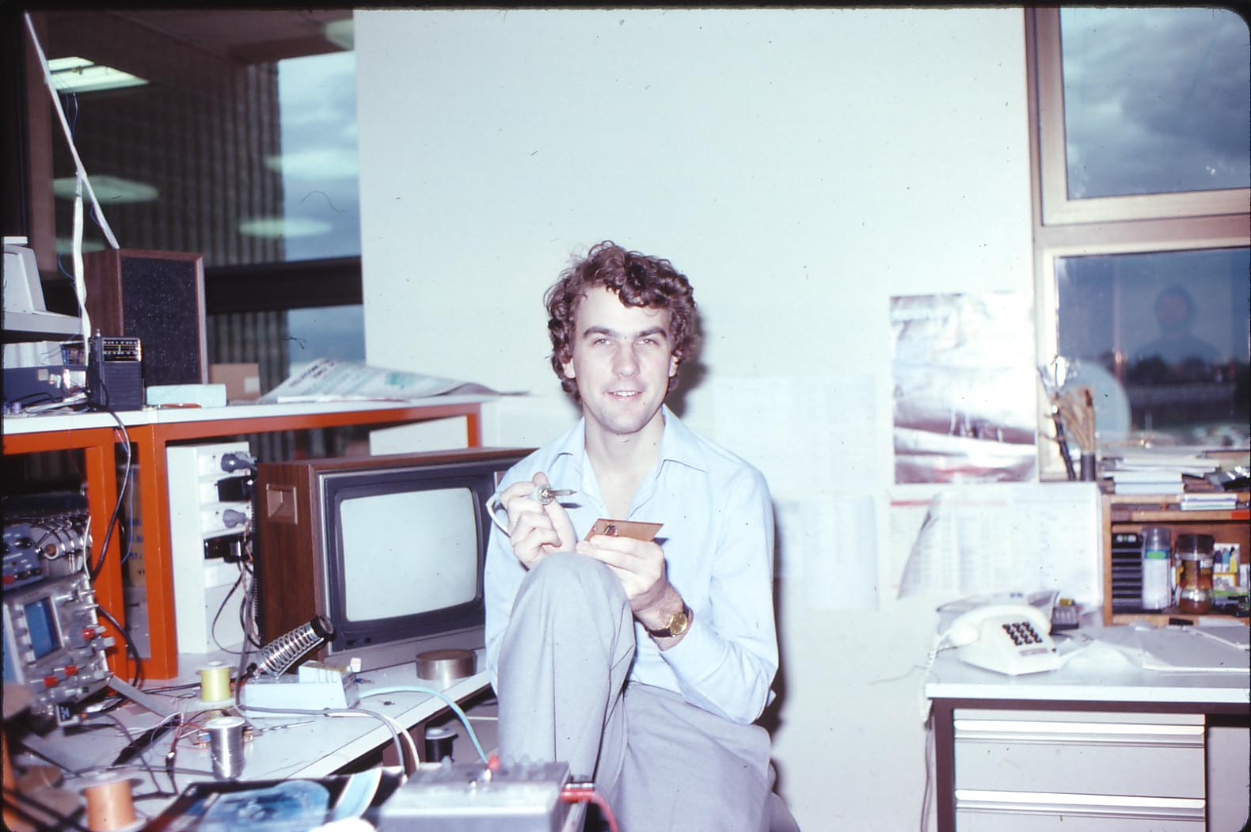

- Stupidest thing done
  - Writing to a consumer electronics manufacturer to complain about product quality using Telecom Australia letter-head (for a product that had not been bought by Telecom)
    - Harry Wragge “carpeted” me for this (circa 1992).

- Smartest idea
  - Disposable Media Player – combines and blurs the relationship between a data-file and a rendering-program.

- Unusual ideas
  - Use of multiple layers of Perspex on a fluorescent light fitting to channel light where needed (for the Telecom Confravision service. (Relies on total-internal reflection like optic-fibres). A prototype was built.
  - Use of a single low-voltage lamp to simulate a point source of light, combined with a shadow-mask to meet ISO lighting requirements specified for subjective image quality testing. Neville Theile liked this idea (of Theile & Small loudspeaker modelling fame).

- Wisest Quote
  - My first Section Head (Max Cassidy) said:
The hardest thing in research is knowing what to do (1981). This simple sentence predicted the next 24 years for me.

- First supervisor
  - Alan Jenkins (1982). See photo below, with a new Apple II computer, along with a Tektronix CRO (now impossible to find in TRL). I’m amazed the Apple II computer is not running “Space Invaders” – but at least we were used an over-the-top-Barco monitor on it!

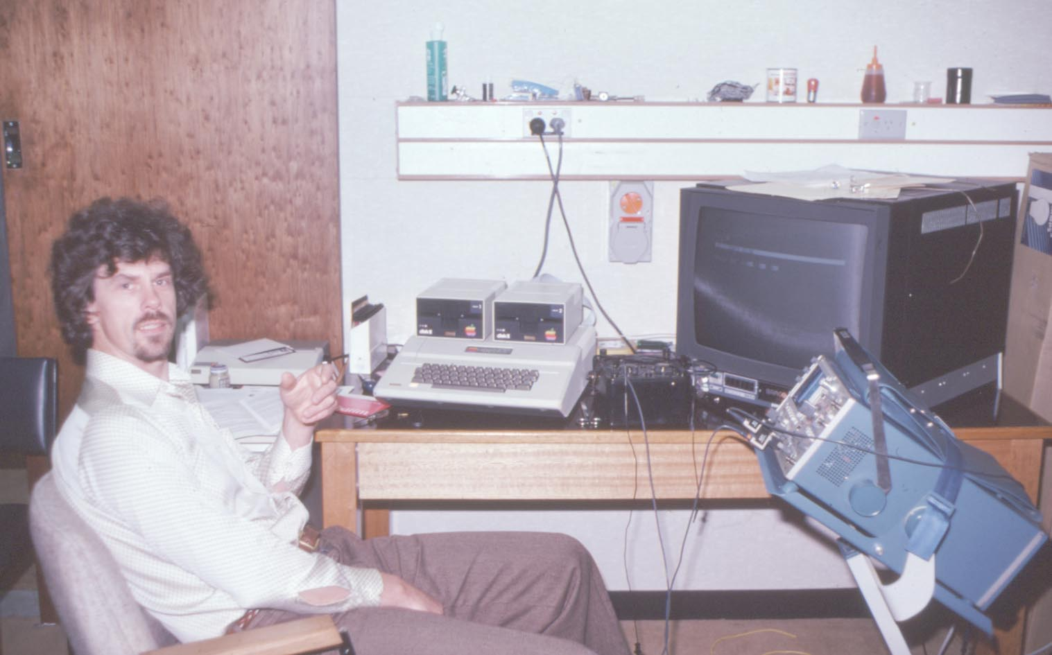

- Riskiest Moment
  - At my job interview, Jim Park asked me if I had heard about packet switching. I said that I had heard of it (on reflection later, I realised I had not). Strangely, Jim Park did not probe me for more information about it (it was usual to find out were the limit-of-knowledge was in job interviews).

- Projects with a Tangible Change or Outcome
  - Speakeasy secure communications adaptor for ISDN & PSTN. Terminals are still in use by the defence department.

- Worst people management
  - Engineer Class-5 (E5) to Senior Technical Officer Grade 2 (STO2), within earshot, standing in the lab, in raised voices – Your personnel file has “do not promote” stamped on it! (1983)
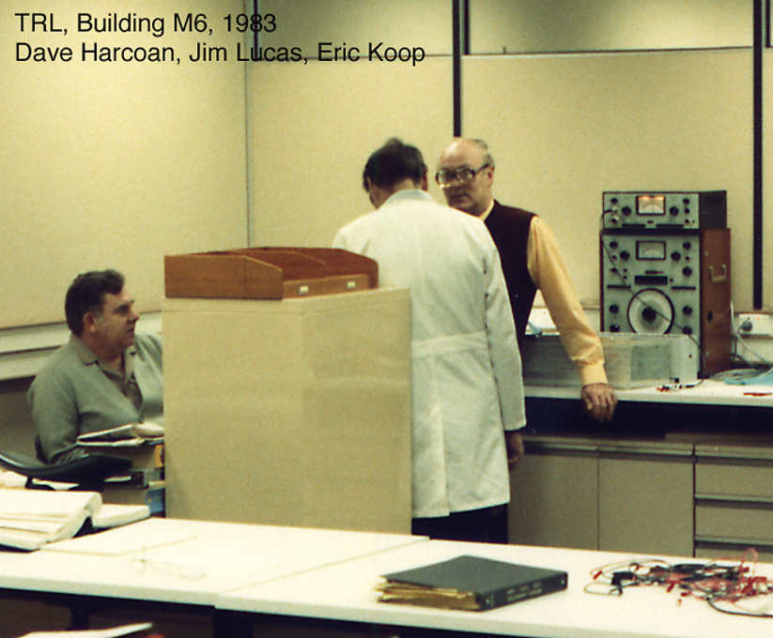

- Best Christmas function
  - The Cuckoo (2004)

- Research Laboratories Reports
  - The publication of Research Laboratories Reports (RLR’s) was the primary method for conveying the outputs of work to other parts of the “Commission”. There was a whole Section of staff dedicated to managing the RLR process (as well as other publications such as Branch Papers and Annual Reviews). When I started Frank Arter and Alan Mitchell were in this Section.
  - For a junior engineer, the publication of their first RLR was somewhat like a passage-of-rights – or that is how it felt to me. In my first year at the Labs (in Business Communication Section), I documented my work on video conferencing as a final report, intending it to be an RLR, but it was never published. It was reviewed by Des Clark (an Engineer Class 4, Section Head of Human Communication Section) who said that it needed a lot of work to get it into shape!
  - In 1982 I rotated to Line and Data Section, headed by Bernie Smith. I reported to John Millott. It was he who taught me how to write a proper RLR.
  - From the mid 1990’s onwards, the publishing of diminished, and was replaced by a new cultures of “slide packs”, created with computer software called Powerpoint. With this culture, all information is placed into a hierarchical structure (even if the information is not hierarchical in nature) of bullet points, which makes it easier to digest, but has the downfall that the finer points are not usually considered.

- Scariest Presentation
  - The third Disposable Media Player presentation to the FORD committee (at the first one, I had been told I was just on a fishing expedition). I drank some Brandy before giving this presentation.
- My worst presentation
  - Reading to Hugh Bradlow, from a pre-prepared script, the proposed project work for a FORD project. (It got me through the presentation, but was laborious for everyone. I also lost a lot of street-cred doing that.)

- Surprising Moments
  - John Ellershaw providing gifts to his staff on leaving TRL (the gift was some free advice:- that I search too long for the perfect answer to things).
  - Jim Lucas kicked a hole in a partition wall, showing frustration with TRL management! His farewell gift was a section of wall ...
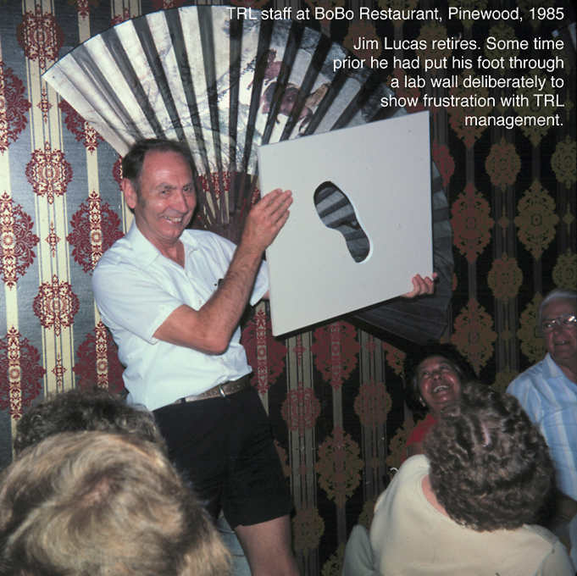

- Best Telstra Course
  - Investment in Excellence (circa 1999)

- Most Stable Work Area
  - Human Communication Section (it changed name many times, but the focus of work was still the same – I feel).

- Sound Recordings
  - TRL Christmas Choir, 1995. Made with the then new gear from the Media Lab. Download it from here:
  - www.coxhill.com/trlhistory/photographs/stevespicer/track8.wav

- Waste of Money/Resources
  - The $30,000 promotional video of the Telstra Media Lab (1996). The tape sat in a cupboard and was never seen.
  - The Employee Opinion Survey. The survey itself is OK, but the actions resulting are where the trouble is.

- Best Answer to a Question from the Floor after a Presentation
  - Steve Spicer to Dr. Nesan Maheswarin
    - “That’s Rubbish!”

- Hugh Bradlow (Director, TRL 1995-2005) at his finest-moment
  - At his Ten Years in TRL slide-pack presentation.

- Some Section-Name History

- Best Pranks
  - Interchanging the top row of digits, with the bottom row of digits, on an early press-button telephone used by Dave Harcoan.
  - A TO2 (Steve Wood) sprayed an IC with instant-freeze while out of the room, and then I believed him when he said that I had stumbled on the invention of a solid-state refrigerator (1982).
  - A paper by Paul Bysouth, Peter Hicks and Jim Park:-
  - In 1995, with newly acquired Photoshop skills, the creation of this photo of Peter Hicks in the Transport Platoon of his National Service Army Regiment (circa 1970). See below:-
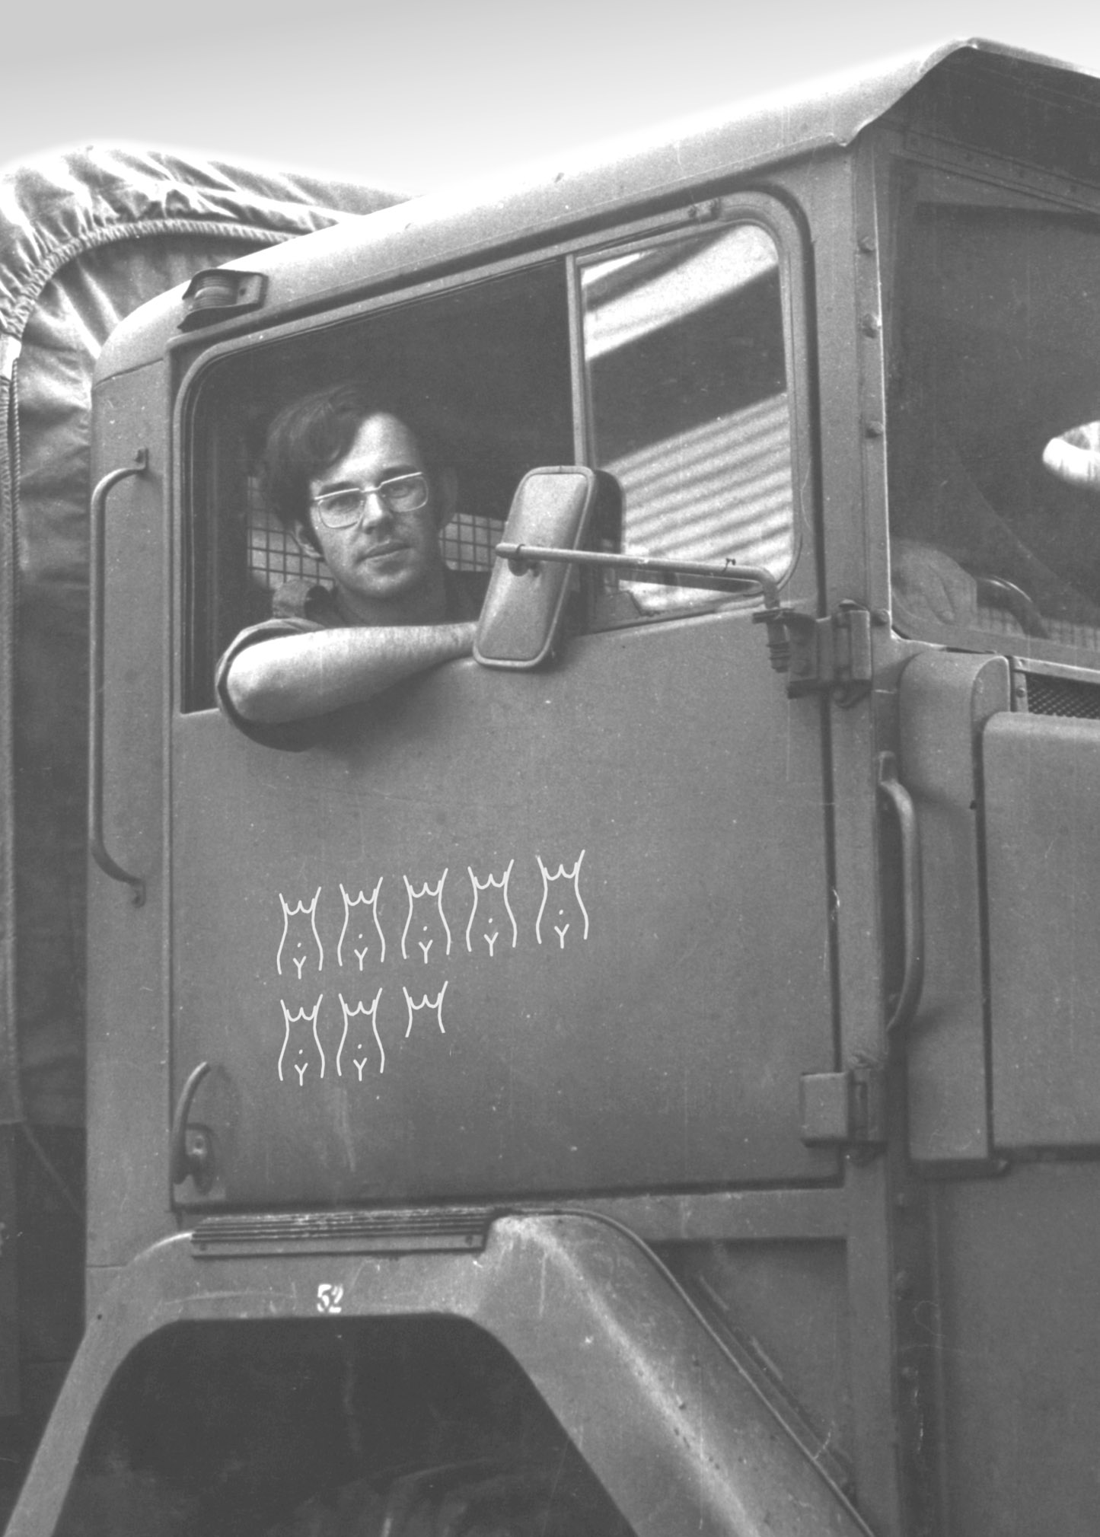

- Regrets
  - Not opening-up enough to all other staff
  - Charging Rick Coxhill about $70 for an Apple computer motherboard, which cost quite a bit less than that.
  - Being on-leave during the Bruno Sorrentino affair.
  - That TRL would not implement this paint scheme (below) for the Clayton site, nor the logo below it.
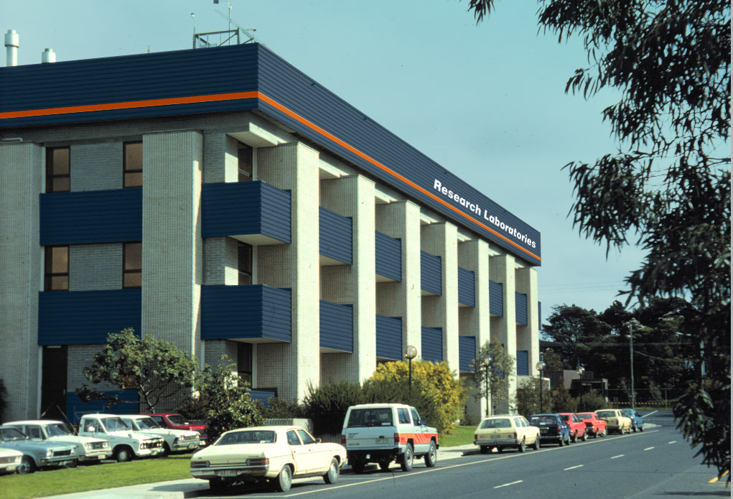



- Changes for the worse
  - Intersection-rivalry, that inhibits the teamwork between Sections, became apparent when client-based funding and marketplace competition appeared.
  - The New-Wave Labs (circa 2000)
  - Maybe even the CTO? (time will tell).

- Best Farewell Message
  - Brian Keck (2006)
”Just woken from a 20 year dream …not all bad”
  - Rick Coxhill - www.coxhill.com/trlhistory/miscell/memories.htm

- Biggest Occupational Health and Safety Risk
  - The current gate-house deign (however, it is OK to have something that is un-safe, just as long as its documented).
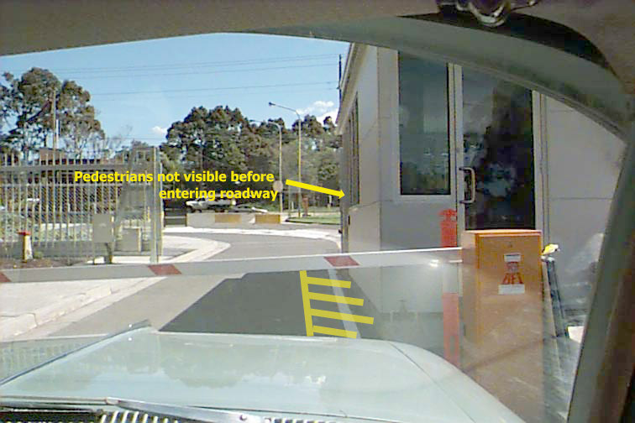

- Report Writing
  - John Millott taught me how to write an RLR. In my first year at TRL, my written report wasn’t published as it need too much work to get it into shape. One suggestion for report writing was:
    - Say what you are going to say
    - Say it
    - Say what you’ve said

- Happiest times
  - 1994 to 2003 – multimedia and video delivery work under Luisa Conte (see below).
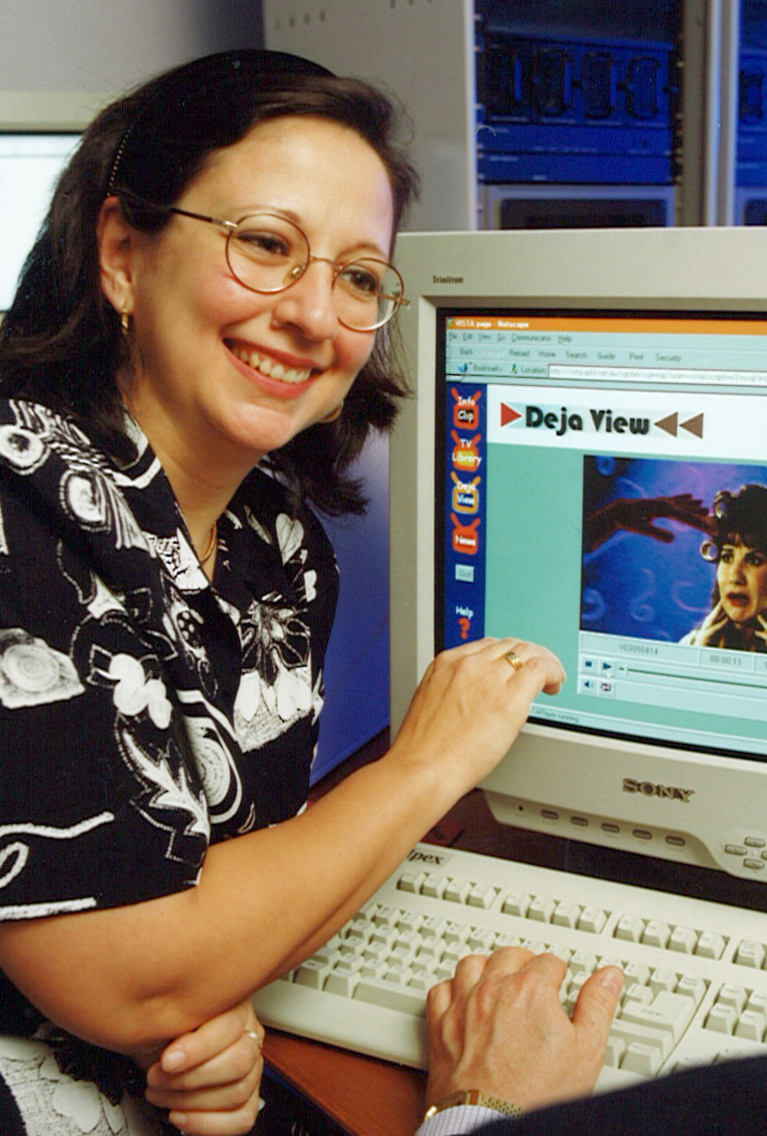

- Not so Happy times
  - Under Winston Tan, building video interfaces for networking

- For posterity – here is the TRL Distribution List before TRL was closed (2005)

- Things that won’t change
  - My car – a 1964 EH Holden
  - You will, somewhere, sometime, see a metallic green EH Holden Premier Station Wagon on the road, and chances are I will be driving it.
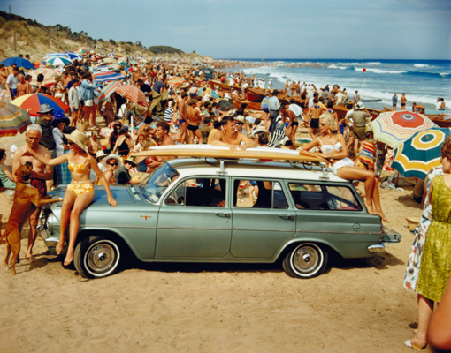



4. SUMMARY.

TRL has been a fantastic place to work. I have benefited far more from TRL, than TRL has from me. I am fortunate to have arrived at TRL at a time when the vision of people like Harry Wragge had been realised. It took 70 years to build TRL, and 10 years to dismantle it.

People say it’s the people here that count and I entirely agree. You have been great – thank you very much.

Stephen Spicer
January 2006.

